**FAQ- INFRA-RED LIGHT CONTROLS**

Pesky light waves stubbornly refuse to turn corners, lose their strength with distance, bounce all over the place causing interference patterns and are also emitted by room lighting, the sun and of course your display which "rather annoyingly" (ha ha) puts out lots of light itself. Unfortunately all these light sources tend to put out light at frequencies in the infrared band in addition to the light waves you can see. Putting an IR receiver right next to your lovely Flat Panel display subjects the infrared light coming in to the various frequencies of light going out, causing interference. The sensor itself generally accepts a wide frequency range and needs to be properly filtered to remove non infrared band signals. The closer the receiver can restrict the incoming light to just the frequencies put out by the remote control the purer the signal will be, and the more reliable the whole system will be.

**DETECT IR SIGNALS FROM THE REMOTE CONTROL**

Use your camera phone to detect if the IR signal is being sent from the remote control.

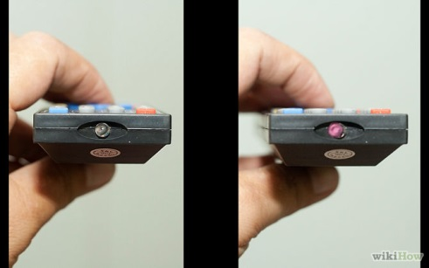

**EFFECT OF AMBIENT LIGHT ON IR SYSTEM**

There are a number of situations where ambient light affects the audio quality of an

IR audio distribution system. They are sunlight, incandescent lamps and fluorescent

lamps operating on conventional electromagnetic and high frequency electronic

ballasts.

If sunlight falls directly on an IR receiver, the phototransistor will be saturated and

considerable amount of noise are generated and this should therefore be avoided. For

venues containing large windows, screening must be used to prevent sunlight falling

directly on receivers or alternatively, additional radiators must be added.

Incandescent light sources such as tungsten filament lamps and halogen lamps, with

and without a dimming facility, emit a high level of IR radiation and will add

considerable amount of noise. It may be necessary to install additional radiators to

compensate.

Tubular fluorescent lamps emit a small amount of IR radiation (See Figure 9 for

spectral distribution of different ambient light sources). When they are operating on

conventional electromagnetic ballasts, the emitted IR is modulated with the mains

supply frequency of 50 Hz and does not present major problems in the IR SI

**COMPACT FLORESCENT LAMP INTERFERNECE**

CFL (compact florescent lamps) lighting are popular alternatives to incandescent bulbs but generate significant amounts of IR noise can impact the performance of other IR control signals.

Electronic ballasts used with florescent bulbs can generate a rapid flicker that can interfere with infra-red signals mimicking the modulation rate of most IR systems.

**WHAT IS INFRA-RED?**

Most remote controls today use infrared light to send a signal from the remote to the device being controlled. Infrared is a form of light which has a longer wavelength than ordinary visible light; it is basically a “color” that the human eye cannot see. It pretty much has the same properties as visible light: it generally passes through transparent surfaces, is blocked by opaque surfaces, and can be reflected. Most sources of visible light give off infrared as well.

**Infrared Emitter, Receivers & Repeaters**

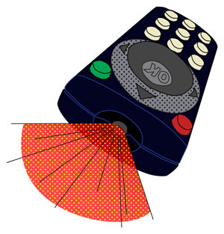Do you wish you could hide your entertainment system in a less obtrusive view, share a Blu-ray player between two rooms or perhaps control your stereo's volume from anywhere in your house? This month's technical article is devoted to the technology needed to accomplish any of the above and more. We will provide the info and parts you will need to soup-up your existing remote control system for more functionality and sure-fire ways to outdo the Jones. Read on, tune in and don't drop that remote...

**IR Transmission Theory**

[Infrared light](https://www.cablewholesale.com/support/technical_articles/infrared.php#ir) transmission has been the standard for [line-of-sight](https://www.cablewholesale.com/support/technical_articles/infrared.php#line-of-sight) type A/V remote controls since the early 1980s. IR transmitters use near-infrared light which is just below the [visible spectrum](https://www.cablewholesale.com/support/technical_articles/infrared.php#visible-light) [Factoid: remote control IR transmitted signals can be seen with digital cameras and camcorders as appearing to be visible, purple light]. By using near-IR wavelengths, manufacturers can use cheap, plentiful, IR [LEDs](https://www.cablewholesale.com/support/technical_articles/infrared.php#led) which are nearly identical to their visible-light counterparts save for emitting frequencies just below what the human eye can detect.

Unfortunately, infrared light as a transmission medium does have its drawbacks in the form of many other competing IR sources. The sun, light bulbs, fluorescent bulbs, fireplaces and in fact, anything that radiates heat, also radiates infrared light. Using IR for a remote now sounds like a recipe for disaster right? Wrong. Thanks to some applied modulation theory, the transmitted infrared signal will not be swamped by interference from other light sources.

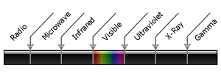  
Electromagnetic spectrum

**Signal Modulation**

IR signals can be modified to blink at chosen frequencies high enough to to stand out over most atmospheric [EMI](https://www.cablewholesale.com/support/technical_articles/infrared.php#emi). This is accomplished by modulating a signal with a [sinusoid](https://www.cablewholesale.com/support/technical_articles/infrared.php#sinusoid) carrier signal of frequency between 30 and 100 kHz. [Factoid: you can test to see if your IR remote is working by using it while pointed at a AM radio tuned to static. You should hear an oscillating sound above the static if the IR remote is transmitting].

  
**Block diagram of modulated IR transmission and reception**

Older remotes with only a single channel used the presence of a carrier signal to engage a function. Later systems with multiple channels (for multiple functions: volume control, change channel, change input type, etc.) modulate the carrier signal with a different frequency for each function. These frequencies are separated out after the initial signal is demodulated with appropriate analog filters. Current IR remote systems transmit digital packets of data along a single carrier frequency. Digital data allows for simpler and less expensive filters as well as a smaller parts count using [integrated circuits](https://www.cablewholesale.com/support/technical_articles/infrared.php#ic).

**IR Emitters**

IR emitters are small wired transmitters for repeating an infrared signal from your remote to an isolated piece of A/V equipment. They are available in single or dual emitter packages with the latter emitting the same signal through two separate housings. Furthermore, emitters also come in blink or blast-style transmission variations with the former being the most common. Blink-style IR emitters blink visibly as well as in infrared and are used to transmit data to a single component source. Blast-style emitters on the other hand, transmit data into several component sources at once and are used when space is a premium. Blast-type emitters are considered a somewhat less reliable transmission method than blink-type.   
  
IR emitters of each type are typically comprised of a mono, 3.5 mm jack attached to the red, plastic-housed transmitter end via a thin, 10 foot cable. The standard installation of remote IR emitters is to attach the transmitter end directly to the source equipment's IR window with self-adhesive. However, the transmitter end can also be placed several inches up to feet away from the receiver such as hidden on the inside of a stereo cabinet door or shelf.

*[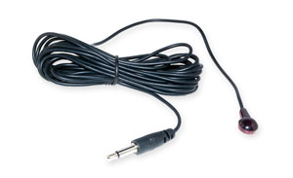](https://www.cablewholesale.com/cgi-bin/articlelink.cgi?article=WEBART_2011-01&key=2b909368b40000514719e32d05f0669345b878b4&link=/specs/332-500.php)*

*Blink-style IR emitter*

**IR Receivers**

These devices pick up infrared signals from your remote control just like a TV or Cable box. After receiving an IR signal they encode and amplify it to be suitable for transmission via low-voltage wiring. Receivers must be located in the room you wish to use the remote control since they require line-of-sight transmission. The cable from the receiver to the connection block needs to accommodate both signal data as well as power since the receivers are [active devices](https://www.cablewholesale.com/support/technical_articles/infrared.php#active). Using Category 5e or Category 6 wire (either UTP or STP varieties), remote signals can be transmitted several hundred feet without significant losses.

**Connection Blocks**   
Connection blocks provide a place for connecting the IR receivers, emitters and their respective power requirements. These devices typically support multiple IR receivers which are all wired in parallel. Each receiver can be provided with a return status indicator signal if applicable. Connection blocks usually support up to six emitters which connect into the unit via 3.5 mm mono phone jacks. Most installations call for the connection block to be located close to the emitters and the supported components such as within a stereo cabinet or hidden out-of-sight in a closet. For convenience connection blocks can be mounted directly to a wall or a shelf with screws.

**How To Increase Your Remote's Effective Angle**   
One chief complaint users have with IR remote controls is their line-of-sight limitations. While this problem can be solved with many of the IR extenders/repeaters described above for use across multiple rooms, their use may seem to be overkill for use in a single room where the angle between the remote and the associated receiver is too steep. Typical remote control receivers allow for around a 60 degree reception angle in front of the device. However, this angle can be drastically increased with a simple fix that would make MacGyver proud: matte Scotch tape. Just apply a small strip to cover the sensor on the IR receiver and enjoy a wider effective angle for your remote control. The matte tape acts similar to frosted glass in [refracting](https://www.cablewholesale.com/support/technical_articles/infrared.php#refraction) incidental beams of IR light after they pass through it. For non-geeks: this translates to generating many beams of light, all at separate angles and at less strength than the original light beam. This spread of refracted beams should be picked up by the receiver within reason.

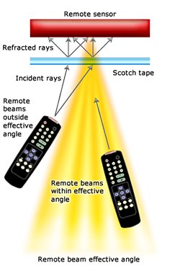

**Silly Questions You Were Afraid To Ask**

* **Q:**Why can I shoot my remote through clear windows but not walls?
* *A:* Infrared light, like visible light, is comprised of waves. These waves can penetrate transparent objects such as glass or clear plastic but may lose energy and due to refraction. Solid objects such as walls, ceilings, furniture and mirrors will allow a limited amount of reflection of an IR wave.
* **Q:**Can you help me program my VCR?
* *A:* Unfortunately, no one actually knows how to program those devices...

**Terms and Definitions**

* Active device: A type of circuit component with the ability to electrically control electron flow.
* Electro magnetic interference (EMI): An electromagnetic disturbance that degrades or limits the effective performance of electronic or electrical equipment.
* Infrared light (IR): Electromagnetic radiation with a wavelength between 700 mm and 300 um, which equates to a frequency range between approximately 1 and 430 THz. IR radiation is just below visible light on the frequency spectrum.
* Integrated circuit (IC): A miniaturized electronic circuit manufactured in the surface of a thin substrate of semiconductor material.
* Light emitting diode (LED): A semiconductor light source which are available in infrared, visible and ultraviolet wavelength variants. LEDs are becoming increasingly popular in consumer electronics, automobile and home lighting due to their high efficiency and long life spans.
* Line-of-sight propagation: This refers to electromagnetic radiation traveling in a straight line. These waves may be diffracted, refracted, reflected or absorbed by atmosphere and obstructions with material and in general cannot travel behind obstacles.
* Refraction: The change in direction of a wave due to a change in its speed as it passes through a medium.
* Sinusoid (a.k.a., sine wave): A mathematical function that describes a smooth repetitive oscillation. This function is commonplace in mathematics, physics, electrical engineering and many other fields. A sine waveï¿½s most basic form is a function of time (t): *y(t) = A ⋅ sin(ωt + φ)*
* Structured cabling: A building telecommunications cabling infrastructure consisting of a number of standardized smaller element subsystems.
* Visible spectrum: The portion of the electromagnetic spectrum visible to the human eye. Electromagnetic radiation in this range of wavelengths is called visible light or simply light. Human eyes will respond to wavelengths from about 390 to 750 nm which correspond to a frequency band in the vicinity of 400ï¿½790 THz.

TUTORIAL ON INFRA-RED TRANMISSION-Link

<http://dkc1.digikey.com/us/en/tod/VishaySemiconductor/InfraredReceivers_NoAudio/InfraredReceivers_NoAudio.html>

**Question**

**When testing an infant (with VRA) or a child (with conditioning play), is it appropriate to use separate codes for speech awareness/threshold testing (92555) and tonal testing (92582 and 92579)? Do VRA and CPA codes include speech testing or tone testing only?**

**Answer**

The CPA code (92582) may be filed with 92555 (speech audiometry threshold) as speech awareness testing is not included in the CPA code descriptor. CPT code 92579, visual reinforcement audiometry, does include speech stimuli as well as frequency specific information from 500-4000 Hz, in the sound field.   
  
*Debbie Abel, Au.D., is the director of reimbursement and practice compliance for the American Academy of Audiology and a former member of the AAA Ethical Practices Board and the American Academy of Audiology Board of Directors. She was in private practice for 13 years in Alliance, OH and currently still sees patients on a limited basis in Poway, CA.*